**CLOUD TRAIL**

Steps to follow:

1. Go to CloudTrail

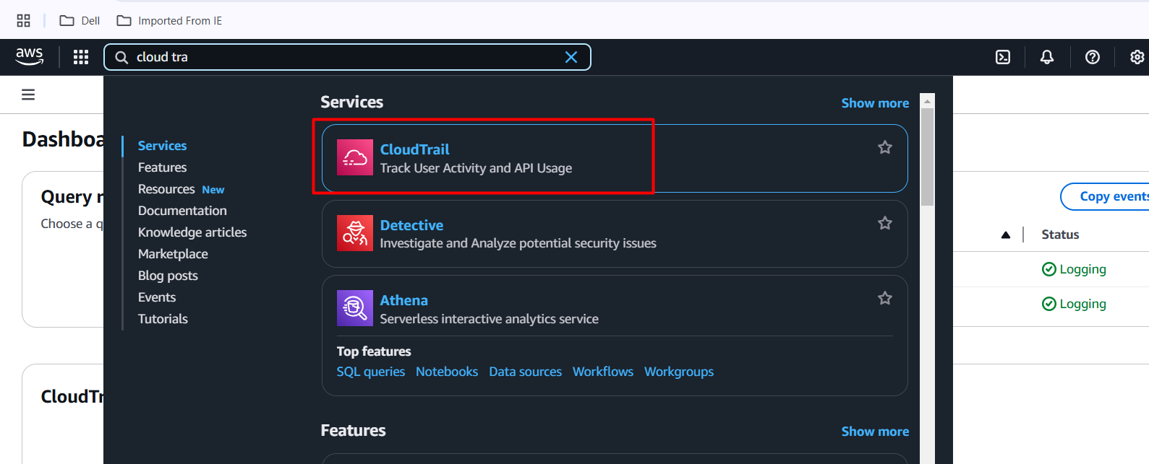

1. Create a CloudTrail

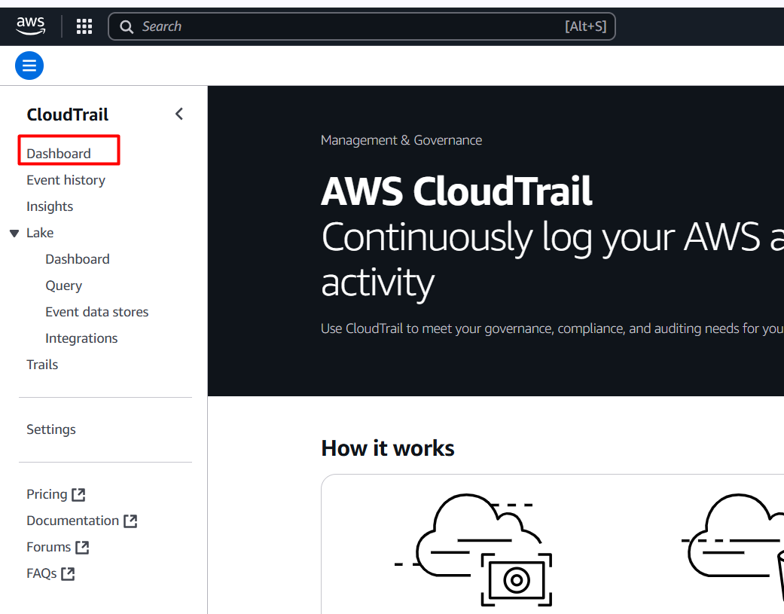

Select create Trail

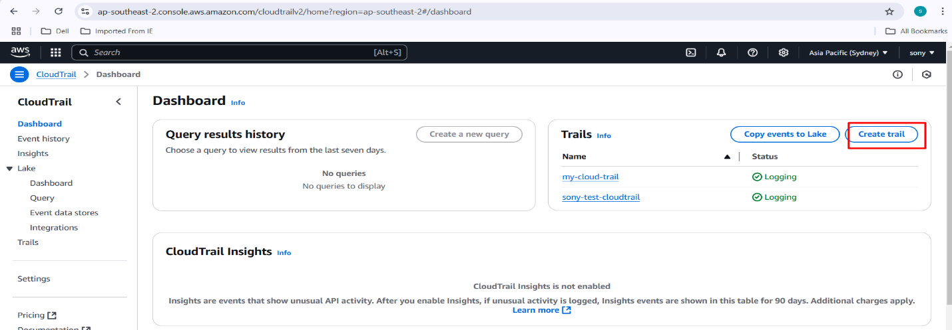

Enter the display name for your trail

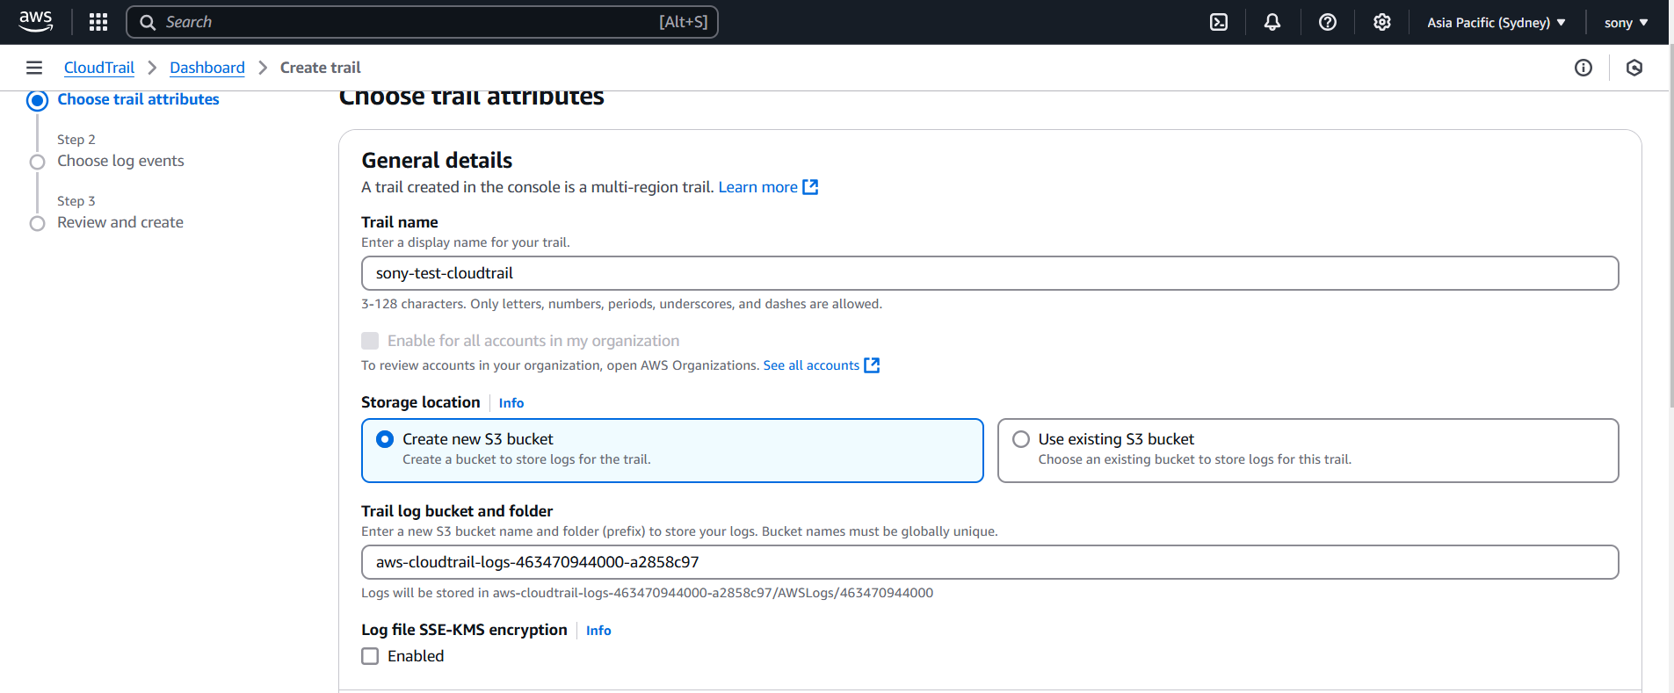

It will create a s3 bucket in the name of aws-cloudtrail-logs-463470944000-5837e5cf. You can add required name.

Uncheck Logfile SSE-KMS encryption and logfile validation as we are not require now.

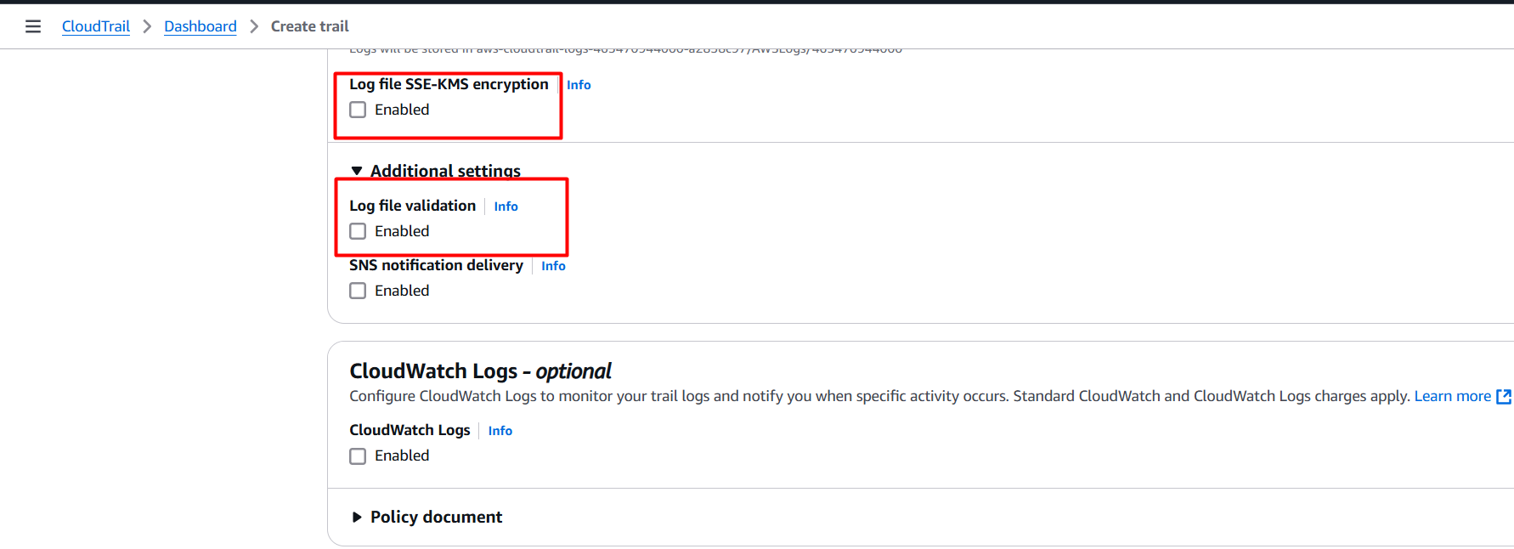

Review and create a trail

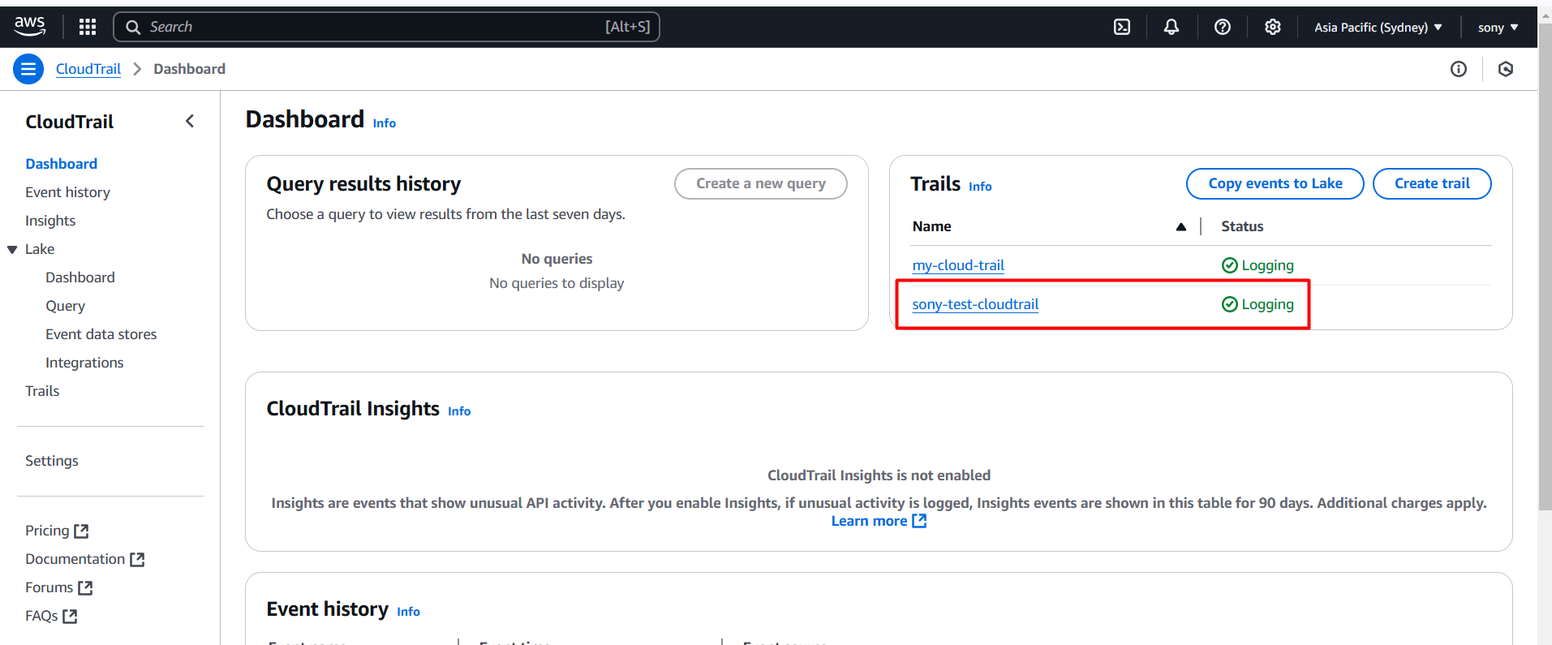

1. Check S3 buckets

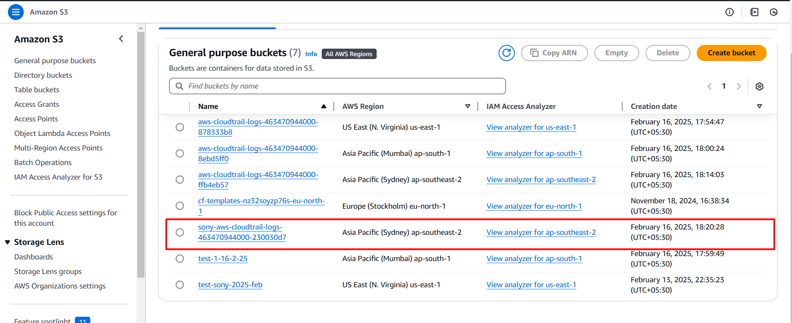

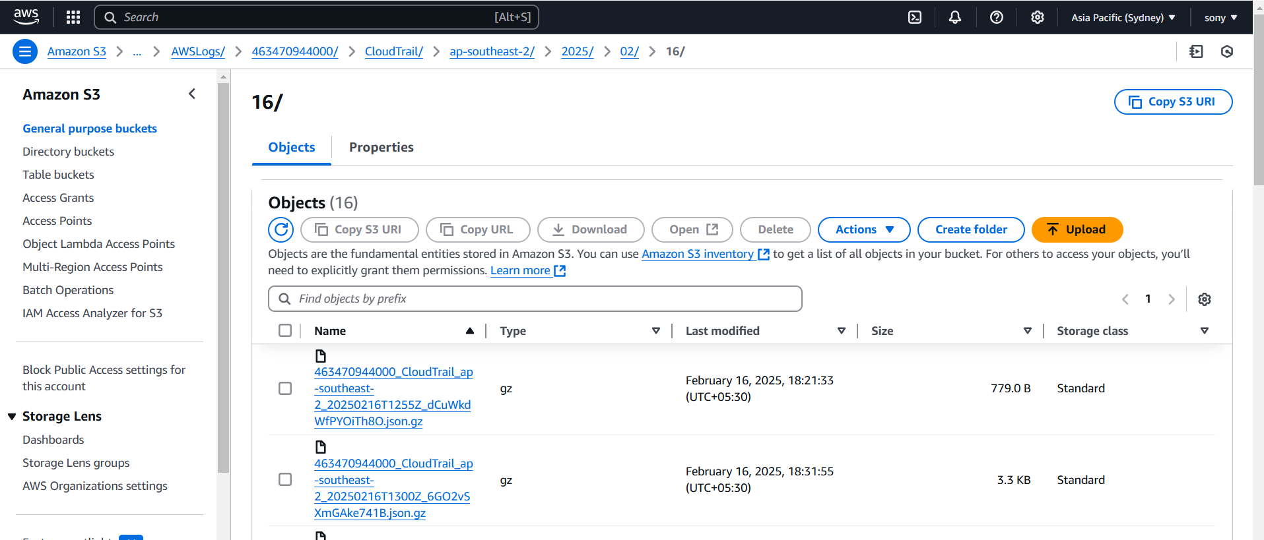

1. Come back to cloud trial and select Event history:

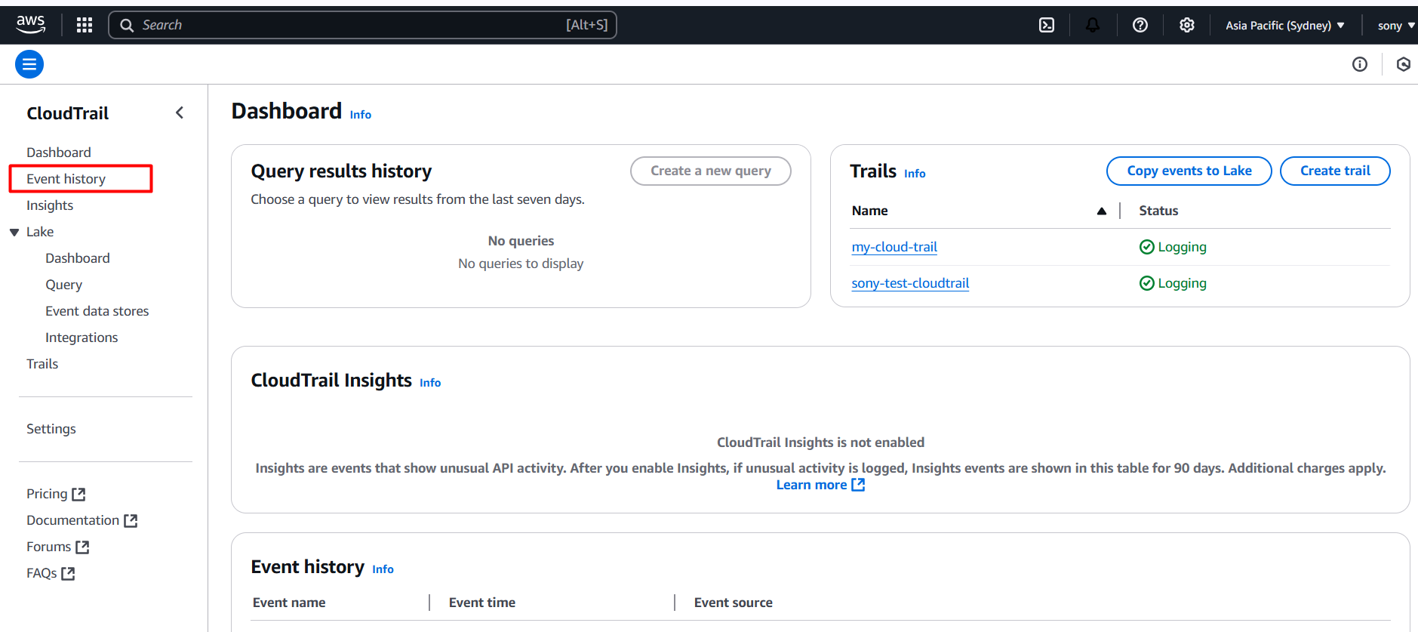

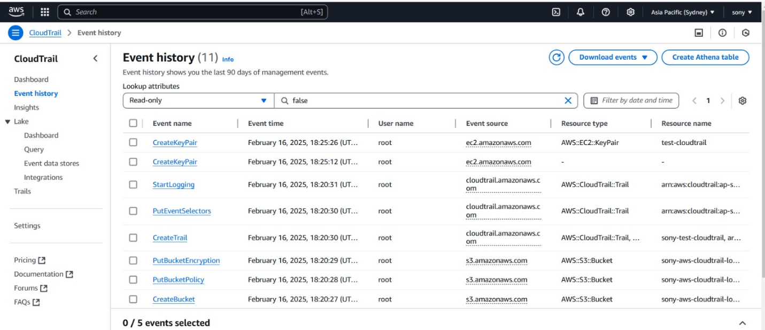

1. Create a IAM user and give S3 and EC2 full access and login to console using IAM user and create S3 bucket and EC2 instance and delete them check whether that is reflecting in Event History or not

